Cards 24 Tutorial Document

Step 1: From the main Cards 24 Screen, click “Start Game” to initialize the first set of random cards. Please note each card is represented as follows:

* 2 – 10 ( will represent the number show on the card , respectively)
* Ace = 1
* Jack = 11
* Queen = 12
* King = 13

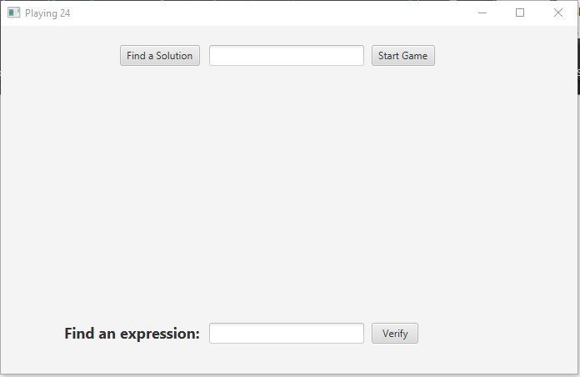

Step 2: Enter an expression using the four whole numbers from the cards generated as seen below:

(in this example the appropriate numbers used should be 5,3,10, & 8)

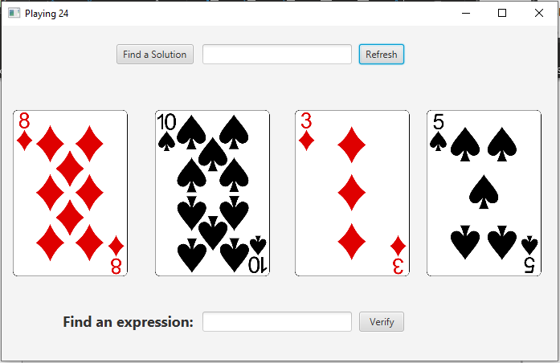

Step 3: Enter an expression in the “Find an expression” field combining the four arithmetic operator (addition, subtraction, multiplication, & division) as well as parenthesis with the perspective numbers of the randomly generated cards.

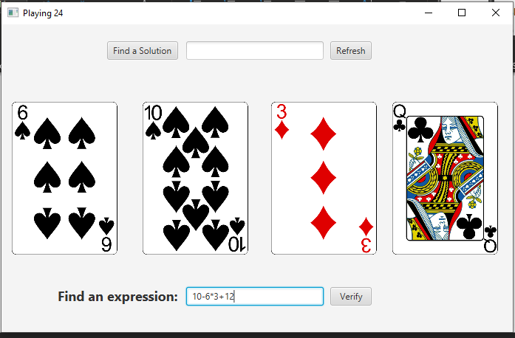

Step 4: Following the input of the expression , hit verify to confirm if the numbers inputted match the provided random generated cards and this will also confirm if the result of the expression evaluates to 24.

